

**Software Engineering**

**Group Alpha**

**Group Members**

**Beresford Groenewaldt : 201308739**

**Tuahafeni Shishiiveni : 200640739**

**Sanette Sheetekela : 201305744**

**Gift Musweu : 201310548**

**Chisanga Nyambe : 201401757**

**Table of content**

1. A brief description of the client you plan to work with, including a rationale for why you chose this client…………………………………………………………………………….
2. A brief description of the problem you will analyze……………………………………….
3. A preliminary analysis of the project requirements………………………………………..
4. A motivation of the agile method ………………………………………………………….
5. A brief communication plan how will you keep in contact with the client to report progress……………………………………………………………….................................
6. Feasibility study for the project chosen…………………………………………………….
7. A short report that summarizes the requirements and the methods you used to gather these requirements, and other relevant discussions you had with the client………………………………………………………………………………………..
8. Document any interesting lessons learned during the elicitation process………………….
9. UML Diagrams
   1. Class diagrams…………………………………………………………......................
   2. Use case diagrams……………………………………………………………………
      1. User and admin use case………………………………………………………..
      2. Tabular description of the ‘Customer’ use case………………………………..
      3. Tabular description of the ‘Customer’ use case………………………………..
   3. State case diagrams…………………………………………………………………..
      1. State case diagram for buying……………………………………………….....
      2. State case diagram for rent……………………………………………………..
   4. Sequence diagram……………………………………………………………………
10. Pattern
    1. MVC……………………………………………………………………………………
11. Architectural design…………………………………………………………………………..
    1. Home page………………………………………………………………………….......
    2. Décor page…………………………………………………………………...................
    3. Wedding dresses page…………………………………………………………….........
    4. Quotation request page…………………………………………………………………
    5. About us………………………………………………………………………………..
    6. Contact us………………………………………………………………………………
12. Test cases

Test case 1…………………………………………………………………………………….

Test case 2…………………………………………………………………………………….

Test case 3…………………………………………………………………………………….

1. References...…………………………………………………………………………………..
2. **A brief description of the client you plan to work with, including a rationale for why you chose this client.**

ELS event supply Cc is a company that deals with events. They hire out and sell tents, chairs and wedding gowns. They operate their business in Namibia only. Any customer that need to book any of the mentioned above products they need to visit their website for detailed information. The reason why they decided to change their booking pattern from manual to web based system is because it helps them to manage the customers booking easily and it is also reliable. This will also help the administrators to keep track of their customer’s online booking request and be able to give a quick feedback to their customer’s request. We chose this client because we feel like the website would be a great platform to exhibit her products and also extend the business exposure to all the potential customers. Through this she is also able to reach out to as many clients as possible, as the website would be accessible from anywhere around the country.

1. **A brief description of the problem you will analyze.**

Our client, ELS event supply Cc, has an issue with efficiently acquiring clients remotely, and as a result ELS is experiencing few problems which are affecting the development of the business. According to our observation and different information gathered, we came to a conclusion that, the business has a very hard time advertising their business to people all over Namibia. The other problem we encountered was the conflicts that arise when the customer’s wants to make a booking, and also the misunderstanding that arise when the customers makes a booking of what is not available in stock. This usually happens due to the database which is not implemented to store all the information about each client and their information.

Our client has an issue with professional exposure by not having a website where there is a thorough review about the company and what they offer to customers. Because the company has so many things to offer, it is difficult to express it all in one post on any social media, not that it is not a good way of business exposure, is that the customer needs clarity on what the business is offering.

1. **A preliminary analysis of the project requirements**

We will be creating a website for the client, which will be used for the selling and hiring of event equipment like tents, table cloths, chairs etc.

Preliminary analysis:-

* 1. There will be code validation to make sure there are no mistakes.
  2. The website has a database containing all the details of the client and the event associated with the client so we will make sure the database of the website is updated.
  3. All information is collected of all the items that to be put on the website like the items with the correct price etc.
  4. With the client meetings, we will analyze that all requirements are not met.

1. **A motivation of the agile method**

According to (Somerville, 2009) agile development is referred to a phrase used to describe methodologies for incremental software development. So what agile basically does it breaks down larger projects into small and manageable chunks called iterations, unlike in waterfall project management which is strictly sectioned.

The reason why we chose to use agile method is because it’s the most effective method used when developing small systems, since it focuses on keeping code simple. Agile method also reduces overheads in the software process and to be able to respond quickly to changing requirements without excessive rework. The other reason why we chose agile method approach is because of the customer’s involvement. What happens here is that the customers provides and prioritizes new system requirements and evaluate the iterations of the system. Furthermore, agile method is used for incremental delivery. Here the customer is able to specify the requirements that are to be included in each increment. In agile approach, embracing changes is also easy as we are able to accommodate the changes that are to be made to the design. Lastly, agile empowers teams to continuously re-plan their release to optimize its value through development, allowing them to be a competitive as possible in the market place.

1. **A brief communication plan how will you keep in contact with the client to report progress.**

The client is a very busy business person and she travels a lot, and setting up a fixed meeting timeline with her in person could be somehow difficult at times. However, she highlighted that whenever she is not available for a meeting with Alpha, she would always offer her full cooperation and support via phone or email.

1. **Review the feasibility study for the project you have chosen.**

A feasibility study is an analysis of the viability of an idea through a disciplined and documented process of thinking through the idea from its logical beginning to its logical end. The purpose of feasibility study is carried out in order to assess the viability of a new project, since this is the primary and most important thing in development of a project.

**Project description**: ELS event supply Cc is a small company that deals with events and hires out and sells tents, table cloths, chairs, wedding gowns etc. This company has recording details of its members which are done manually on paper. Registering new member is very slow and files are easily lost.

The feasibility study we choose for our project, is the market feasibility because with this we are able to determine facility needs, suitability of product technology, availability and suitable of site and other inputs.

**Objective and solutions**: we want to grow the business by creating a website that can be used to do all the booking remotely and sell items in an efficient manner. By doing this, the registration process is also made faster, secure and reliable since it saves time, resources and can be accessed by everyone, anywhere and anytime.

**Feasible Conclusion**: The website will be a great and wonderful platform and it’s a tool that can boost and showcase the company on a bigger scale to the nation and the world.

1. **Write a short report that summarizes the requirements and the methods you used to gather these requirements, and other relevant discussions you had with the client.** 
   1. **Functional requirements**

According to (Somerville, 2009), Functional requirements defines the fundamentals actions that the system must perform. Furthermore In some cases, the functional requirements may also explicitly state what the system should not do. Our functional requirements are list below:

* + 1. **Viewing**
       1. The system must be able to allow users to view all available products.
       2. Product information must be displayed underneath each product picture.
       3. The system must go back to the home page if the user clicked on the Home link in the top left corner of the web page.
       4. When the “contact us” link is clicked on the home page, the system must go to the Facebook page of the company hosting the website.
    2. **Booking/rent-out**
       1. Users must be able to rent-out/book event equipment.
       2. System must be able to send a quotation via email to the user that requested one.
       3. The system must request the user to enter their personal details and the details of the event.
       4. Details will be stored on the appropriate database on the premises of the company.
    3. **Buying**
       1. Users must be able to buy or order a product that they desire.
       2. Users must complete an order details form in order to validate the order.
       3. Order details will be stored on the database held on premises.
  1. **Non-functional requirements**

Somerville (2009) stated that non-functional requirements are properties that your system must have. Think of characteristics or qualities that make your system attractive, usable, fast and sure, but they are not required.

* + 1. **Performance**
       1. The system must be able to handle multiple transactions a time.
       2. Quotation emails must be sent within 24 hours of request.
       3. The system must provide customers 24/7 hours online booking service.
    2. **Maintenance/Upgrades**
       1. System down-time must be limited to 30min during day time.
       2. System down-time must be limited to 6 hours during night time.
       3. System down-time must be recorded by the minute.
    3. **Security**
       1. Users are not allowed to view other user purchases.
       2. Users are not allowed to view other user bookings.
       3. Users are only allowed to alter their own personal information.
       4. Only administrator is allowed to alter the information of the users on request by owners.
       5. Customers need to cancel their booking 48 hours in advance, otherwise they will be charged a certain free for late cancellation.

**7.2.4 Methods we used to gather the information.**

We were able to gather all these requirements through phone calls, sit-down meetings, text messages plus a digital advertisement of what they do. With all this information gathered we were able to compile a requirements document with all the necessary user and system requirements needed to continue our development on the system.

1. **Document any interesting lessons learned during the elicitation process.**

In requirements engineering, requirements elicitation is the practice of collecting the requirements of a system from users, customers and other stakeholders. Requirements elicitation is a part of the requirements engineering process, usually followed by analysis and specification of the requirements. During this process we were able to determine whether the stated requirements are clear, complete, consistent and resolving any apparent conflicts.

**The best practices and lessons learned**

* 1. Apply good interpersonal skills: Such skills are always an asset, but they are a necessity when eliciting requirements.
  2. Think broadly: SEs with broad knowledge of the enterprise in which requirements are being developed (whether for a system, service, or the enterprise) adds value and may be able to identify cost-effective solutions (e.g., process changes).
  3. Determine the root cause of the problem**:** Before requirements collection starts, it is critical that the SE answer the question, like what is the real need that the project and its product are intended to address? This way you able to find the best suitable solution to the problem.

1. **UML Diagrams**

UML design is the shortest form of “**Unified Modelling Language**”. The purpose of this modelling language is to visualize the design of the system.

* 1. Class diagrams

This is the most used UML diagram in the field of software engineering design. It is called as a main building block of any object oriented solution. Usually it illustrates the classes in a system, attributes and operations of each class and also the relationship between each class. Below is the “***class diagram***” of our new proposed system.

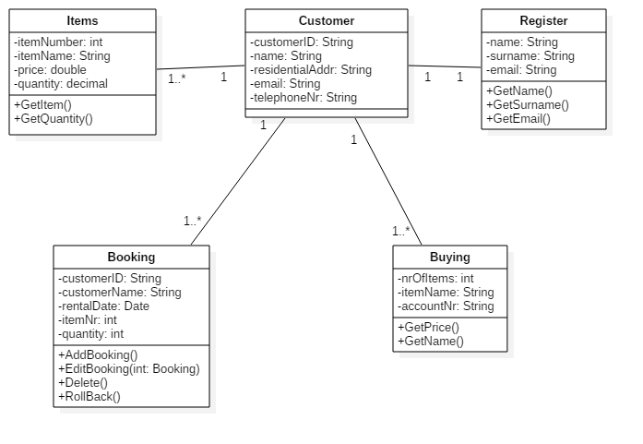

* 1. Use case diagrams

It is also called behavioral UML diagram. It gives a graphic over-view of the actors involved in a system directly. It shows how different functions needed by the actors how they are interacted.

Below is the “***use case diagram***” of our new proposed system.

9.2.1 User and admin use case

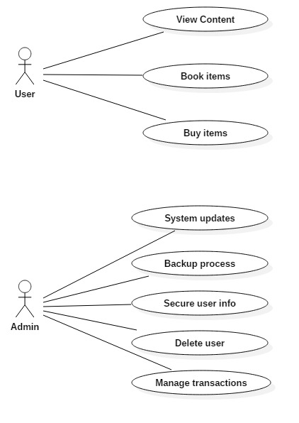

**9.2.2 Tabular description of the ‘Customer’ use case**

|  |  |
| --- | --- |
| Name: | Booking and/or buying |
| Actor: | Customer |
| Description: | Describe the process used to add a new booking or to buy item |
| Successful completion: | 1. Customers can book  2. Customers can buy |
| Precondition | Customers is required to enter/fill in their details |
| Post condition: | Customer is successfully added to the database and booking is made. |

**9.2.3 Tabular description of the ‘Admin’ use case**

|  |  |
| --- | --- |
| Name: | Administrator tasks |
| Actor: | Administrator |
| Description: | Describe the tasks of the admin |
| Successful completion: | 1. Admin can check the booking details  2. Admin updates the customers information  3. will keep the copy of the generated booking confirmation  4. Do backup of the files |
| Precondition: | None |
| Post condition: | Database updates |

9.3 State case diagrams

According to (Somerville, 2009), State case diagrams “show how individual objects change their state in response to events. These are represented in the UML."

9.3.1 State case diagram for buying

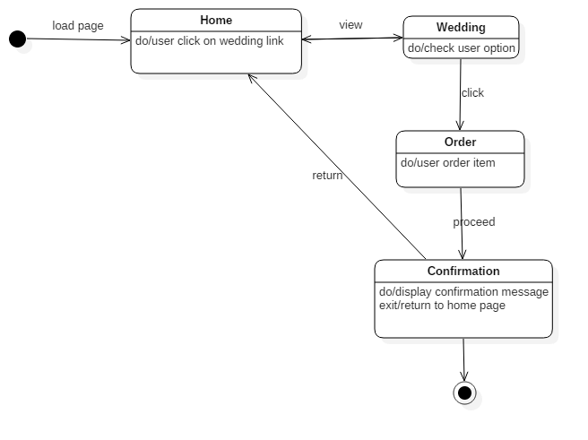

9.3.2 State case diagram for rent

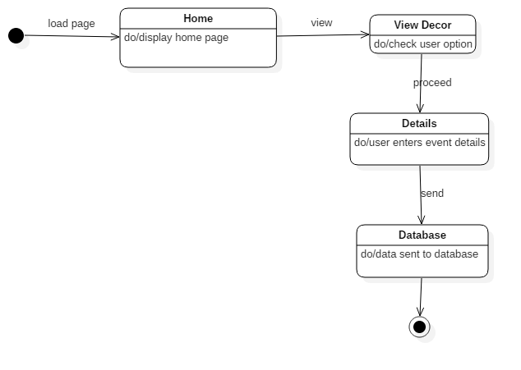

9.4 Sequence diagram

According to (Somerville, 2009), a sequence diagram is a diagram “which show the sequence of object interactions. These are represented using a UML sequence or a collaboration diagram.”

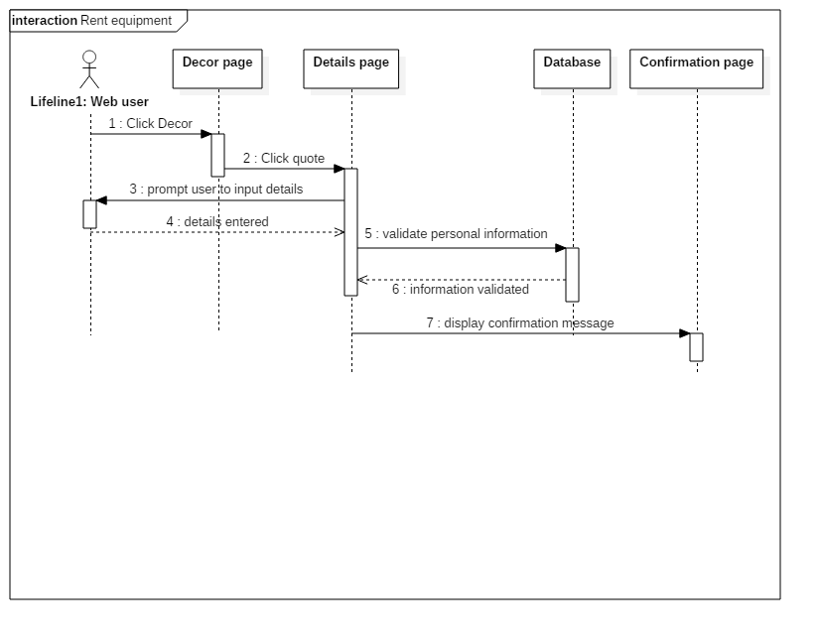

1. **Pattern**

Model View Controller (MVC)

According to (Somerville, 2009), Model-view-controller (MVC) is referred to a type of pattern that separates presentation & interaction from the system data. The system is structured into three logical components that interact with each other, which are:

* The model component, this component manages the system data and associated operation on that data.
* The view component, this component defines and manages how the data is presented to the user.
* The controller component, this component manages interaction and passes these interactions to the view and the model.

We choose this pattern for our system, because MVC let you change the way a view responds to user input without changing its visual presentation. In addition, this model returns data without applying any formatting, the same components can be used and called for use with any interface. Furthermore, the model is self-contained and separate from the controller and the view, it’s much less painful to change your data layer or business rules. The concept of the controller is also a benefit, since it’s used to stitch together different pieces of the model and the view to fulfill a request. This places significant power into the architect’s hands.

Among the drawbacks of using MVC is that it’s not necessarily easy, and it is definitely not for everybody. MVC requires significant planning, and it introduces a deeper level of complexity that requires diligent attention to detail. Overall, this is a good approach to building software. The MVC design pattern is well-established and compelling approach to software.

1. **Architectural design**
   1. Home page

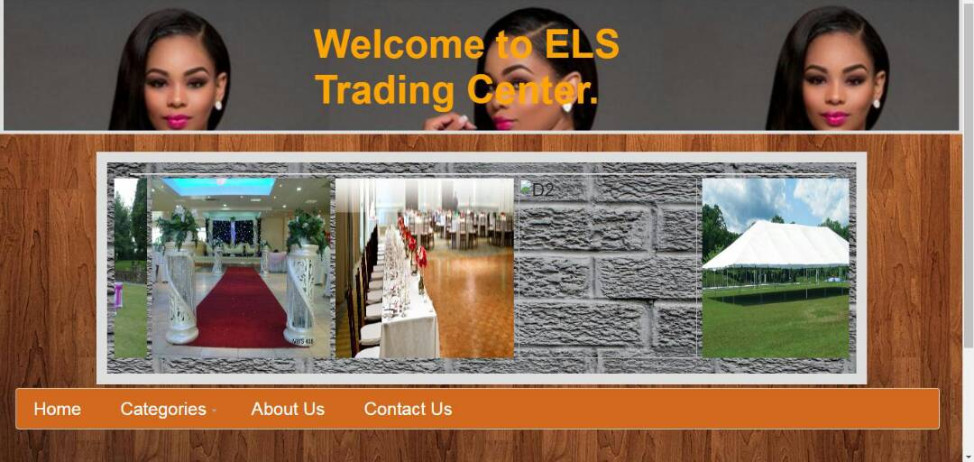

The picture above shows the home page of “ELS trading” web based system. This interface contains the Home, Categories, About Us and Contact Us menu bar. Below is the company’s social link (Facebook). Customers can give their feedback on our social site also.

* + 1. Decor page

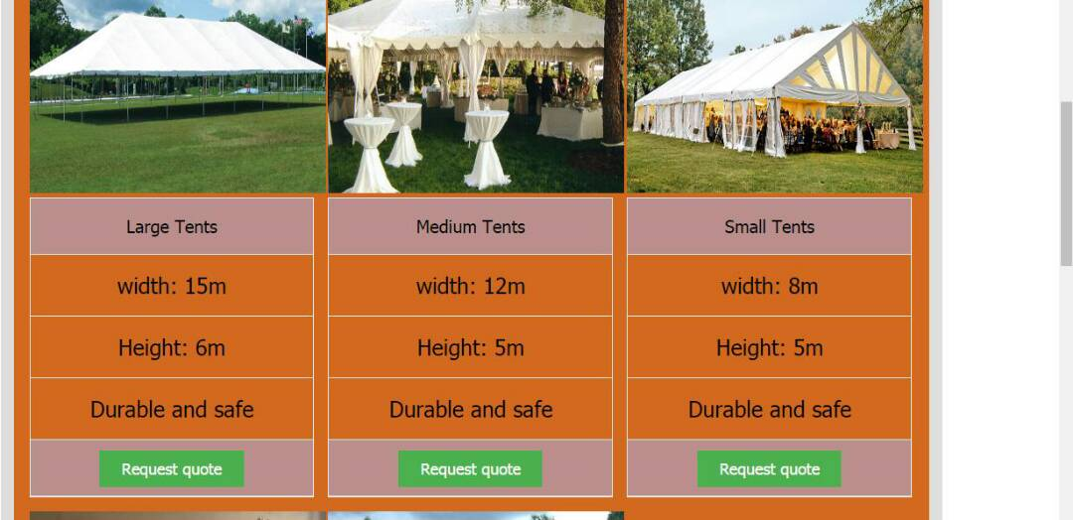

The picture above shows the décor page where the customer can request a quote by pressing the “Request quote” button on the item they desire to book.

* + 1. Wedding Dresses Page

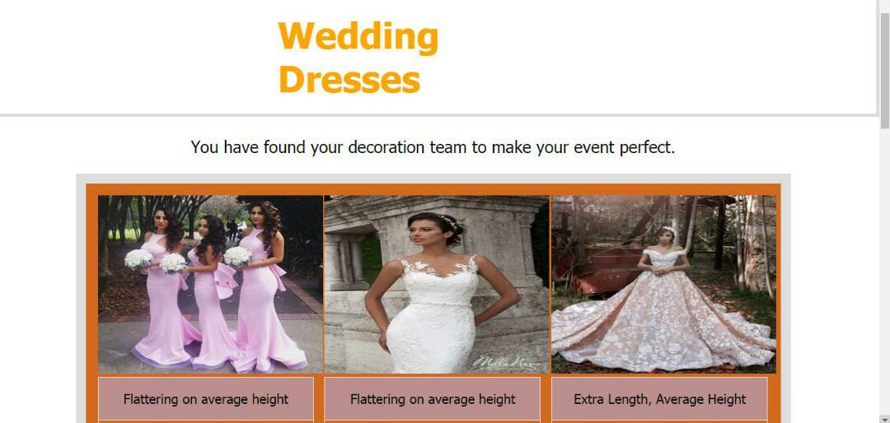

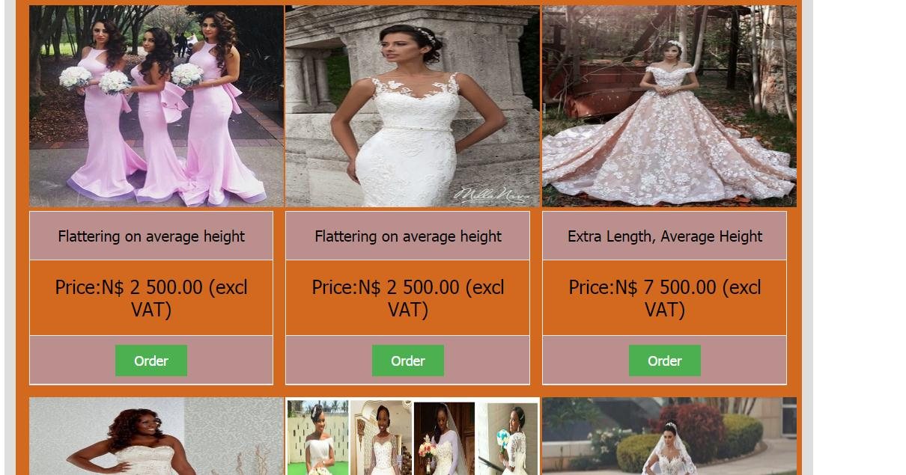

The picture above displays the different wedding dresses that the customer can order.

* 1. Quotation Request Form page

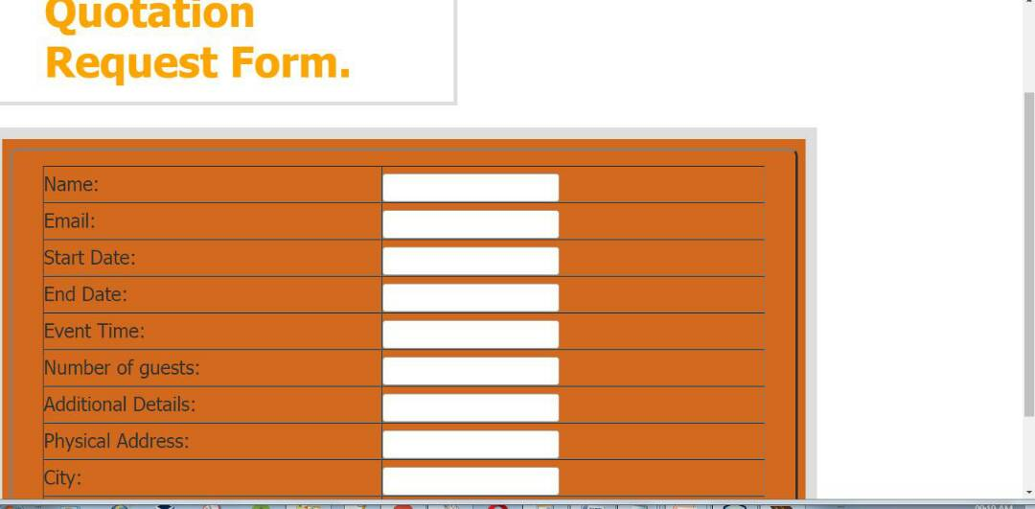

The picture above displays the details that the customer has to enter. If any information is missing or the customer did not accept the terms and conditions, the page will prompt the user to enter those missing information before they can register.

* 1. About Us page

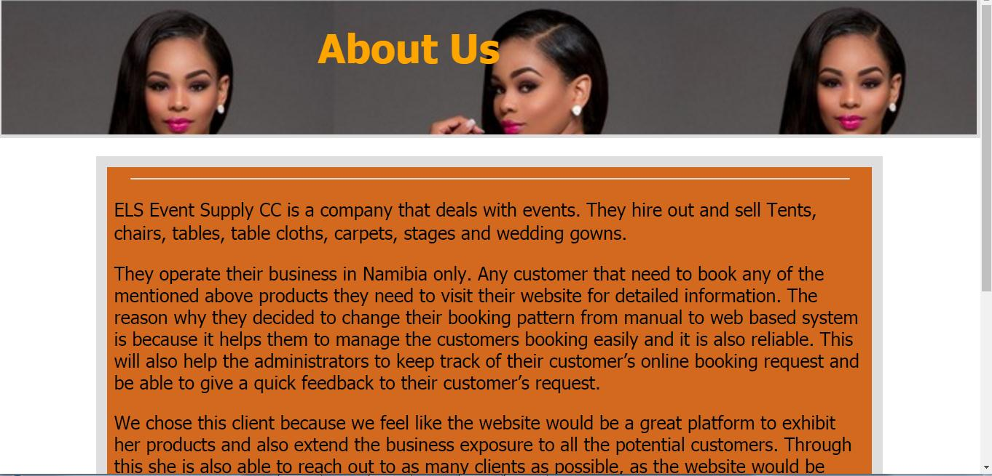

The picture above displays a detailed description about ELS event supply Cc. The customer will have a good idea what the company is all about.

* 1. Contact Us page

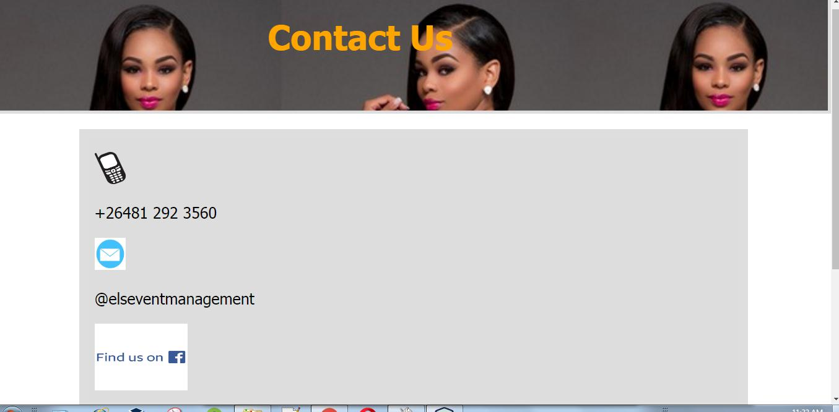

The picture above displays the contact details of ELS event supply Cc. The customer will be able to contact them for more details.

1. **Test Cases**

According to (“Test Case – Software Testing Fundamentals,” n.d.) A test case is a set of conditions or variables under which a tester will determine whether a system under test satisfies requirements or works correctly.

The process of developing test cases can also help find problems in the requirements or design of an application.

**Test Case 1:**

Test Title: Quotation Request Form

Test Procedures**:** Type user name

Test Data: User name must be in alphabetic form. Otherwise the system will show error.

Expected Result: User can proceed to complete the form.



**Test Case 2:**

Test Title: Order wedding dress

Test Procedures**:** User proceed to Quotation Request Form page when Order button clicked.

Test Data: User need to click the Order button to proceed.

Expected Result: It will proceed to Quotation Request Form page.



**Test Case 3:**

Test Title: Find us on Facebook icon

Test Procedures**:** Click on the icon.

Test Data: Users need to click on the Facebook icon.

Expected Result: Users will be redirected to the company’s Facebook page.



1. **References**

Beck, A., Boeing, G., & Shannon, D. (2014).[*"Systems and Methods for Analyzing Requirements. US Patent 8650186"*](http://geoffboeing.com/publications/systems-methods-analyzing-requirements/)*.* Retrieved 2016-03-17.

[Chemuturi,M.](https://en.wikipedia.org/wiki/Murali_Chemuturi)(2013).*Requirements Engineering and Management for Software Development Projects.*[*doi*](https://en.wikipedia.org/wiki/Digital_object_identifier)*:*[*10.1007/978-1-4614-5377-2*](https://dx.doi.org/10.1007%2F978-1-4614-5377-2)*.*[*ISBN*](https://en.wikipedia.org/wiki/International_Standard_Book_Number)[*978-1-4614-5376-5*](https://en.wikipedia.org/wiki/Special:BookSources/978-1-4614-5376-5)*.*

Kotonya, G., & Sommerville, I. (1998). *Requirements Engineering: Processes and Techniques* Chichester, UK: John Wiley and Sons.

Sommerville, I. (2009). Software engineering. United State of America: Addison- Wesley.(“Test Case – Software Testing Fundamentals,” n.d.)

Test Case – Software Testing Fundamentals. (n.d.). Retrieved May 2, 2017, from http://softwaretestingfundamentals.com/test-case/